CHARACTERISTICS STUDY OF SIDE BAND POWER AND FREQUENCIES IN AM USING MATLAB
OBJECTIVES:
i) To generate an Amplitude Modulated (AM) signal in MATLAB using specified carrier and modulating signal parameters.
ii) To determine and verify the upper sideband (USB) and lower sideband (LSB) frequencies of the AM signal using frequency spectrum analysis in MATLAB.
iii) To calculate the carrier power, sideband power, and total transmitted power of the AM signal for a given modulation index using MATLAB.
iv) To analyze the effect of varying the modulation index on sideband power distribution and overall transmission efficiency through MATLAB simulation.

PROGRAM:
clc;
clear;
close all;

%% Parameters
Am = 1; % Message amplitude
fm = 500; % Message frequency (Hz)
Ac = 5; % Carrier amplitude
fc = 5000; % Carrier frequency (Hz)
fs = 20 * fc; % Sampling frequency

%% Time Vector
t = 0:1/fs:4/fm;

%% Objective 1: Generate AM Signal
m = Am * sin(2*pi*fm*t);
c = Ac * sin(2*pi*fc*t);

mu = Am / Ac; % Modulation Index
am = Ac * (1 + mu*m) .* sin(2*pi*fc*t);

% Demodulation
dem = abs(hilbert(am));
dem = dem - mean(dem);

%% Objective 2: Frequency Spectrum Analysis
N = length(am);
f = linspace(-fs/2, fs/2, N);
AM_FFT = abs(fftshift(fft(am)))/N;

USB = fc + fm;
LSB = fc - fm;

%% Objective 3: Power Calculations
Pc = Ac^2/2; % Carrier Power
Psb = (mu^2 * Pc)/4; % Sideband Power (Each)
Pt = Pc + 2*Psb; % Total Power
Efficiency = (2*Psb/Pt)*100; % Transmission Efficiency

%% Display Results
fprintf('\n----------- AM PARAMETERS -----------\n');
fprintf('Message Frequency = %d Hz\n', fm);
fprintf('Carrier Frequency = %d Hz\n', fc);
fprintf('Modulation Index (μ) = %.2f\n', mu);

fprintf('\n----- Objective 2: Sideband Verification -----\n');
fprintf('Upper Sideband (USB) = %d Hz\n', USB);
fprintf('Lower Sideband (LSB) = %d Hz\n', LSB);

fprintf('\n----- Objective 3: Power Calculation -----\n');
fprintf('Carrier Power = %.2f W\n', Pc);
fprintf('Each Sideband Power = %.3f W\n', Psb);
fprintf('Total Power = %.3f W\n', Pt);
fprintf('Transmission Efficiency = %.2f %%\n', Efficiency);

%% Objective 4: Effect of Modulation Index
mu_values = [0.2 0.4 0.6 0.8 1.0];
Power_SB = zeros(size(mu_values));
Power_Total = zeros(size(mu_values));
Eff = zeros(size(mu_values));

fprintf('\n----- Effect of Modulation Index -----\n');
fprintf('Mu\tSideband Power(W)\tTotal Power(W)\tEfficiency(%%)\n');

for i = 1:length(mu_values)

mu1 = mu_values(i);

Psb1 = (mu1^2 * Pc)/4;
Pt1 = Pc + 2*Psb1;
Eff1 = (2*Psb1/Pt1)*100;

Power_SB(i) = Psb1;
Power_Total(i) = Pt1;
Eff(i) = Eff1;

fprintf('%.1f\t%.3f\t\t\t%.3f\t\t%.2f\n', ...
mu1,Psb1,Pt1,Eff1);
end

%% Plots
figure('Name','AM Modulation','NumberTitle','off');

subplot(3,2,1)
plot(t,m,'LineWidth',1.5)
title('Message Signal')
xlabel('Time (s)')
ylabel('Amplitude')
grid on

subplot(3,2,2)
plot(t,c,'LineWidth',1.5)
title('Carrier Signal')
xlabel('Time (s)')
ylabel('Amplitude')
grid on

subplot(3,2,3)
plot(t,am,'LineWidth',1.5)
title('AM Signal')
xlabel('Time (s)')
ylabel('Amplitude')
grid on

subplot(3,2,4)
plot(t,dem,'LineWidth',1.5)
title('Demodulated Signal')
xlabel('Time (s)')
ylabel('Amplitude')
grid on

subplot(3,2,5)
plot(f,AM_FFT,'LineWidth',1.5)
xlim([fc-3*fm fc+3*fm])
title('Frequency Spectrum')
xlabel('Frequency (Hz)')
ylabel('Magnitude')
grid on

subplot(3,2,6)
bar([Pc Psb Psb Pt])
set(gca,'XTickLabel',{'Carrier','USB','LSB','Total'})
title('Power Distribution')
ylabel('Power (W)')
grid on

%% Effect of Modulation Index
figure('Name','Effect of Modulation Index','NumberTitle','off');

subplot(2,1,1)
plot(mu_values,Power_SB,'-o','LineWidth',2)
xlabel('Modulation Index (\mu)')
ylabel('Sideband Power (W)')
title('Sideband Power vs Modulation Index')
grid on

subplot(2,1,2)
plot(mu_values,Eff,'-s','LineWidth',2)
xlabel('Modulation Index (\mu)')
ylabel('Efficiency (%)')
title('Transmission Efficiency vs Modulation Index')
grid on

OBJECTIVE 1 - To generate an Amplitude Modulated (AM) signal in MATLAB using specified carrier and modulating signal parameters.
OUTPUT:
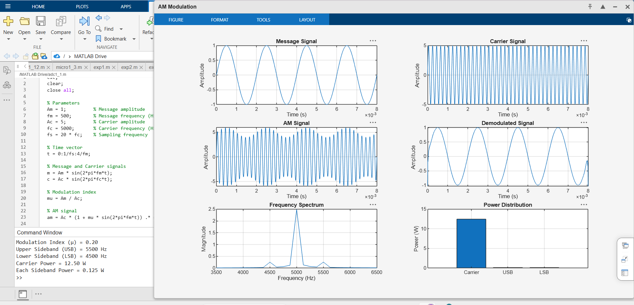

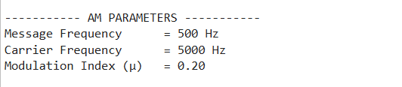

OBJECTIVE 2 - To determine and verify the upper sideband (USB) and lower sideband (LSB) frequencies of the AM signal using frequency spectrum analysis in MATLAB.

OUTPUT:


OBJECTIVE 3 - To calculate the carrier power, sideband power, and total transmitted power of the AM signal for a given modulation index using MATLAB.

OUTPUT:

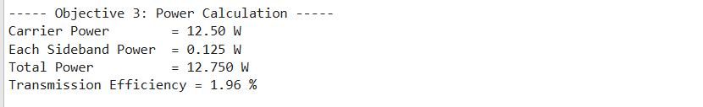

S

OBJECTIVE 4 - To analyze the effect of varying the modulation index on sideband power distribution and overall transmission efficiency through MATLAB simulation.

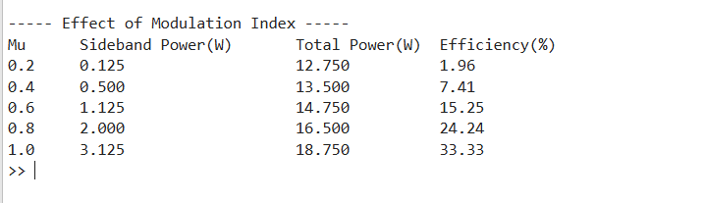
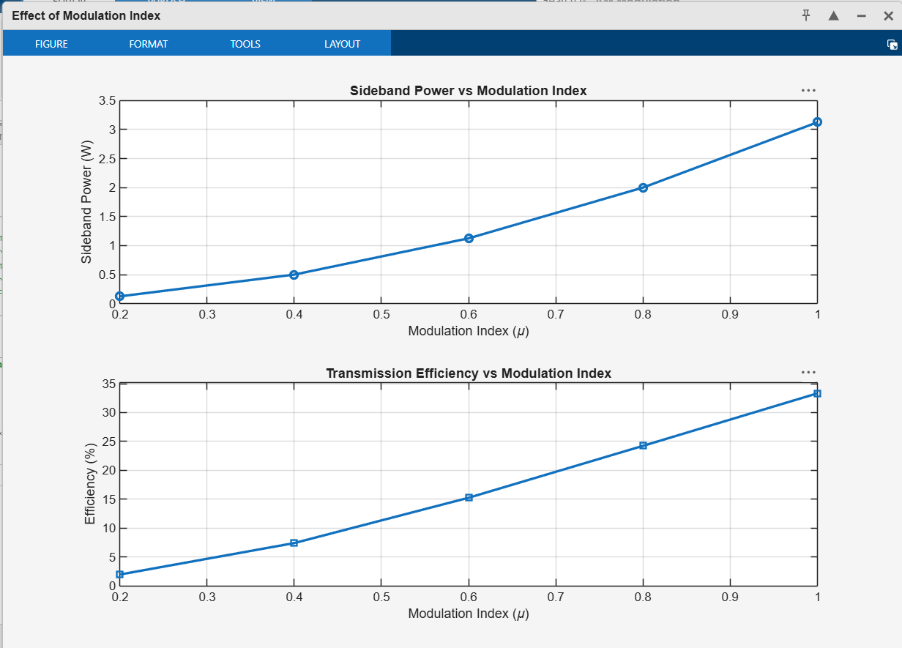
OUTPUT:

